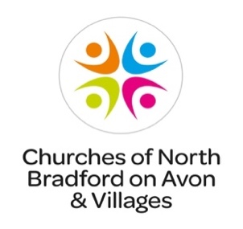
St Peter’s church,
Monkton Farleigh

Annual Parochial Church Meeting

10.00am on Tuesday, 23 April 2024
in St Peter’s church

All are welcome to attend to hear about the life of your village church

Refreshments will be served

