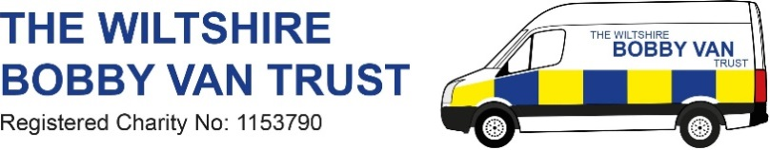
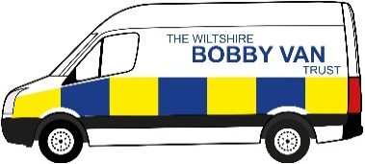
If your passionate about making a difference become a Wiltshire Bobby Van Stay Safe On-line Volunteer.

We are committed to ensuring our volunteers feel valued and recognised for everything they do.

- This is a role suited to someone who is reliable, has time to commit to about one day a week and wants to make a real difference, to not only the safety and security of vulnerable people, but also the feeling of security when using the internet. Online exploitation and fraud are the fastest growing area of crime, and the elderly are particularly a target.

- Volunteers will visit and work with individuals in their own homes assessing how they use their internet and smart technology; then provide advice and guidance to make them less likely to become a victim of crime and to feel safer using the internet. Volunteers can also give group talks where the volunteer will provide an input with the same goals, but to community groups and organisations. We will give up to date information and advice on computer & internet security.

- The successful applicant will receive an Induction which will include - an overview of WBVT to include administrative procedures, DBS Check, the loan of IT equipment if required & reimbursement for travel expenses plus accompanying an existing volunteer to a 1 to 1 home visit and a group talk. You will need to have access to a car or the means to be able to travel to different locations to carry out referrals.

For further information contact Toni Evans
WBVT Stay Safe Online Manager Email: Toni@wbvt.org

