Melksham & Bradford on Avon Neighbourhood Policing Teams – Rural Beats
We understand that often those living in our more rural communities can feel isolated.
As a Community Policing Team we are committed to engaging with residents in our local villages and talking about the issues affecting those living and working there.
The aim of Neighbourhood Policing is to have a dedicated policing team in your local community. We are here to work with you to tackle local concerns raised by you. We work with residents and local agencies to improve your quality of life.

There are 4 Police Constables currently attached to the Melksham & Bradford on Avon Neighbourhood Policing Teams- two per town. Whilst these officers are predominantly responsible for the Town patches, each constable has been given a rural geographical area of responsibility.

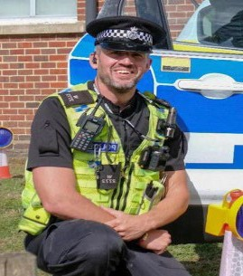 | 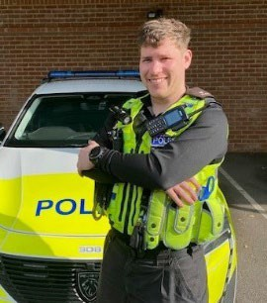 | 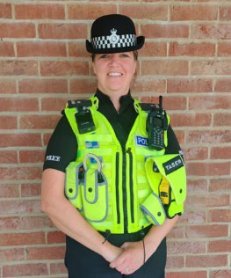 | 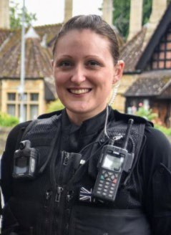 | 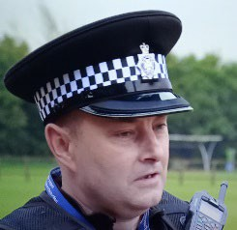  Inspector Andy Lemon
PC Ben Coombs  Sandridge Redstocks Broughton Gifford Norrington -Common Atworth  Shaw Whitley Beanacre Forest | PC Elliott Holdsworth  Steeple Ashton Keevil Bulkington Poulshot Inmarsh  Seend  The Stocks Semington Seend Cleeve | PC Jen Miller  Holt  South Wraxhall Bradford Leigh Staverton Monkton Farleigh Farleigh Wick Little Chalfield Great Chalfield | PC Rachel Jackson  Conkwell Little Ashley Winsley Turleigh Avon Cliff Westwood Wingfield  Limpley Stoke | 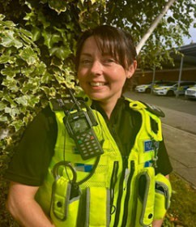  Sergeant Gemma Rutter

Email the Neighbourhood Policing Team at TrowbridgeAreaCPT@wiltshire.police.uk
Melksham: ben.coombs@wiltshire.police.uk or elliott.holdsworth@wiltshire.police.uk
Bradford on Avon: rachel.jackson@wiltshire.police.uk or jennifer.miller@wiltshire.police.uk
Follow us on Facebook – Facebook/MelkshamPolice or Facebook/BradfordonAvonPolice
To contact Wiltshire Police or to report a crime or incident call 101
Only call 999 in an emergency when a crime is in progress
If you want to give information anonymously about a crime call Crimestoppers on 0800 555 111

