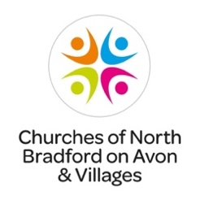
St Peter’s church,
Monkton Farleigh

DATES FOR YOUR DIARY

7:30pm on Saturday, 29th July
Opus 5 Woodwind Quintet concert,
£10 including a glass of wine.
Call 01225 851485 for tickets
Sunday, 3rd September in afternoon
Choral concert by Canzona, a local choir, followed by tea and cakes.
Donations on the door

7:30pm on Saturday, 14th October
Bath Male Choir concert at St James church, South Wraxall.
This is a fundraising event for both St Peter’s and St James churches.
Tickets £10 - call 01225 858412

