Monkton Farleigh Village Hall
presents

Coronation ‘Bring and Share’ Tea
Sunday 7th May
3-5pm
at the Village Hall

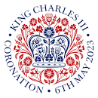

Please come along and join us to celebrate the
Coronation of King Charles III.
Just bring a plate of something to share and maybe a folding chair if you have one - we will provide the tea, coffee and squash.
Crown decorating for children !
Hope to see you there!

